Mining Transparency: Assessing Open Science Practices in Crime Research Over Time Using Machine Learning
Abstract
This pilot study addresses the current lack of systematic, large-scale evidence on Open Science Practices (OSPs) adoption in criminology and legal psychology. A scalable, machine-learning-based text classification pipeline is introduced to map the prevalence of Open Access (OA), Open Data (OD), Open Materials (OM), and Preregistration (PR). The analysis is based on publication metadata and a year-stratified sample of full texts from the top 100 journals in Criminology & Penology, Law, and Psychology (2013-2023). After identifying articles containing statistical inference (SI) via a high-performing classifier, the author utilized GPT-assisted coding and supervised learning to train specific classifiers for OD, OM, and PR. OA was classified using publicly available metadata. Among 1,763 SI articles with usable full text, design-based estimates reveal a significant disparity in OSP adoption. OA is relatively common (40.9%, 95% CI: 38.8-43.1) and has steadily increased from approximately 20% in 2013 to 50% in 2023. By sharp contrast, trends for OD, OM, and PR cannot be reliably quantified. Extreme class imbalance and the minimal number of positive cases indicate a very low underlying true prevalence for these practices in the assessed field. Methodologically, the study confirms that GPT-assisted coding supports accurate SI detection, but robust prevalence estimation for extremely low-frequency OSPs remains challenging for downstream classifiers. Overall, this project establishes a transparent and reproducible pipeline and provides critical baseline estimates for future, larger-scale assessments of research transparency in crime-related fields.

1. Introduction
When evidence makes headlines, influences public opinions, shapes policing, sentencing or rehabilitation, it touches lives. But over the last decades, social scientists have learned how easily impressive results evaporate. Criminology is not insulated from these pressures. In this paper, open science practices in criminology and legal psychology are monitored to assess if the field is wired to catch errors before they might become policy.
“Only by […] repetitions can we convince ourselves that we are not dealing with a mere isolated ‘coincidence’, but with events which, on account of their regularity and reproducibility, are in principle inter-subjectively testable.” (Popper, 2005: 23)
To challenge bias and to support replication of research, a movement has formed within the scientific community, fueled by the “replication crisis” that was especially prevalent within the field of psychology (Dienlin et al., 2021). The open science movement tries to establish open science practices (OSPs) to challenge many of the known biases that endanger the reliability of the scientific process and enable access to the scientific discourse for a broader public Banks et al. (2019). The ongoing debate of the last decades was especially focused on two OSPs:
First, openly sharing materials, data and code enables replication that reduces p-hacking, surfaces errors, spreads methodological knowledge and might reduce burdens on the researcher, driving broader adoption across science (Fink and Marcus, 2024; Freese, 2007; Freese et al., 2022). Second, preregistration involves thoroughly outlining and documenting research plans and their rationale in a repository before conducting the research, reducing deliberate or unconscious decisions taken to improve findings, challenging publication bias and other biases (Hardwicke and Wagenmakers, 2023; Manago, 2023; Mertens and Krypotos, 2019).
The initial plan for this work was to study the proposed effects of OSPs on reported effect sizes in published papers. During a first literature review, it appeared to me that there were only few publications that used preregistration in data-driven Criminology and Legal Psychology. Instead of assessing effect sizes, this raised the question of how OSPs have been adopted within criminology at all. Motivated by the expected positive impact of OSPs, this work studies the use of OSPs in the field.
Scoggins and Robertson (2024) did an extensive analysis of nearly 100,000 publications in political science as well as international relations and observed an increasing use of OSPs, with levels still being relatively low. Their extensive research not only revealed the current state of open science in political science, but also generated rich data to perform further meta research. Inspired by their work, I adopt their research questions to assess OSPs in the fields of criminology and legal psychology:
$RQ_{1}$: What proportion of papers that rely on statistical inference make their data and code public?
$RQ_{2}$: What proportion of statistical inference publications were preregistered?
This work gathers data about papers in a subset of Criminology and Legal Psychology journals, categorizes those papers by application of open science practices using machine learning methods and explore the patterns over time. The methods will closely resemble and try to improve the approaches taken by Scoggins and Robertson (2024). The research will contribute to the ongoing discussion about the use of OSPs by painting a clearer picture of their adoption in the field. The improved approach will serve as a starting point for a more extensive exploration of OSPs in criminology and legal psychology and will contribute to the growing literature of machine learning and LLMs in classification tasks of scientific literature.
But first, a closer look at the underlying issues leading to the recent development of the open science movement will be taken to gain a deeper understanding of its context, the intended goals, implemented methods and their expected impact on the ever progressing scientific discourse.

2. Background
In his widely reviewed standard reading “Seven rules for social research”, Firebaugh (2008) emphasizes the importance of the reproduction of research findings. But already in the title of the chapter or the rule itself, Firebaugh cuts back on his appeal: “replicate where possible”. He notes increasing data availability, yet acknowledges challenges for true replication. Given the books influence since 2008, one might expect replication and replication-enabling practices to be widely adopted today. But is this the case?
Besides the theoretically driven discourse, there are quite tangible reasons to talk about the scientific method, replication and the publication process. Analyzing 77 research teams assessing the same dataset for a single hypothesis, Breznau et al. (2022) found extremely diverse results, ranging from strong positive to strong negative outcomes. They termed this phenomenon “researcher degrees of freedom”, explaining that most of the variance in results was not explained by assigned conditions, research decisions, or researcher characteristics. Instead, idiosyncratic researcher variability accounted for more than 90% of the variance.
This raises the question: if modern research practices are so prone to bias and error, what steps can be taken to mitigate these issues? A closer look at an ongoing debate resulting from cases around replication failures helps shed light on the whole complex, its implications and the today’s research culture.

2.1 From Replication Crisis to Credibility Revolution?
The publication of Firebaugh’s text coincided with the onset of the replication crisis, a period where widespread replication failures especially but not exclusively in psychology revealed systemic issues in research culture. This crisis wasn’t limited to a few fraudulent cases but exposed a broader problem where seemingly robust, highly cited studies could not be reproduced. Examples ranged from unintended to outright data fabrication (Bargh et al., 1996; Callaway, 2011; Crocker, 2011). While the crisis began in psychology, it soon spread to other fields like in political science and economics (Breznau, 2021). For instance, a classic social priming study by Bargh et al. (1996), finding that participants primed with an “elderly” stereotype walked more slowly, failed to replicate. A follow-up-study suggested, that the original results were likely influenced by experimenter expectations rather than the hypothesized mechanism of unconscious priming (Doyen et al., 2012). While some extreme cases are well-documented, the crisis is largely seen as a result of systemic pressure and normal human behavior or misconduct than in serious intent (Crocker, 2011; Diekmann, 2022; Firebaugh, 2008).
The term crisis not only implies alarmingly high proportions, but also creates pressure to act. This is supported by findings spanning many fields: Finance (Jensen et al., 2023), economics (Briggs, 2023), sociology (Auspurg et al., 2014) or medicine (Begley and Ellis, 2012), with some authors even claiming that most published research findings in the social sciences are false (Ioannidis, 2005). But what drives this crisis?

2.2 Questionable Research
One of the earlier discussed practices that distort scientific progress is called publication bias. Rosenthal (1979) defines it as the preference for publishing positive over negative or inconclusive results. This, often institutionally driven bias, also called the ‘file drawer problem’, can occur at any stage in research (Franco et al., 2014; Kühberger et al., 2014). Contributing practices include selective reporting, where null findings or variables are omitted from analysis (Breznau, 2021) and the post-hoc adaptation of hypotheses (Gerber and Malhotra, 2008). But Breznau et al. (2022) don’t see publication bias as the main driver of the huge variance in results. Instead, they emphasize the role of idiosyncratic researcher variability and the broader context of research practices, leads to the problem of science practices that might produce unreliable or invalid results: so-called questionable research practices (QRP).
A truth-incentivizing survey of over 2000 psychologists revealed a high prevalence of QRPs. Around 60% admitted to not reporting all dependent measures, 50% to selective reporting, and 30% to falsely claiming they predicted an unexpected finding. About 2% even confessed to data falsification (John et al., 2012). Criminology shows similar patterns, though with lower rates due to the absence of incentives (Chin et al., 2023).
In their excellent manifesto for reproducible science, Munafò et al. (2017) conceptionalize QRPs along the typical stages of empirical research. Common QRPs include HARKing or presenting an unexpected exploratory finding as a preplanned hypothesis, p-hacking or manipulating data or analysis to achieve a desired p-value and selective reporting, that is not reporting studies or variables that lack significant results. Other QRPs involve undisclosed data exclusion, stopping data collection when a desired result is found, or not reporting all conditions or measures used. These practices inflate false-positive rates and undermine research credibility (Auspurg et al., 2014; Breznau, 2021; Chin et al., 2023).
Other problematic practices involve the misuse of p-values, where researchers simply misinterpret the significance level as the likelihood of truth in their findings, leading to vast overconfidence in their results-that can also be a consequence of or lead to a failure to control for bias and poor quality control (Breznau, 2021; Munafò et al., 2017). Demographic, geographic or political biases and peer review limitations are more sources for error (Breznau, 2021; Grossmann, 2021a). Additionally, gendered penalties favor men publishing disproportionately more than women Akbaritabar and Squazzoni (2021). Misaligned institutional incentives, also accelerated by an intense competition for academic jobs, tenure and funding, lead to a so-called “publish or perish” culture (Breznau, 2021; Smaldino et al., 2019).
All the above leads to the conclusion, that our institutions make refutation harder than confirmation. Open science (OS) is the design response, resetting defaults to transparency, pre-specification, and reproducibility. Munafò et al. (2017) translate that philosophy into a lifecycle blueprint: blinding and preregistration, stronger methods training and independent oversight, open data, code and diversified peer review to harden reproducibility, evaluation and other measures. The central movement to address the above issues is the OS movement, devoting its effort to challenge publication bias, low statistical power, p-hacking, HARKing and other problems by increasing reproducibility and transparency (Grossmann, 2021a).

2.3 Open Science Practices
Following an extensive literature review, Vicente-Saez and Martinez-Fuentes (2018) characterize OS using four differentias: transparency in communication, accessibility or searchability to all data and materials, sharing of everything with a commitment to do so and collaboration along a scientific, distributed global dialogue throughout all stages involved in science. They integrate these into a succinct definition: “Open Science is transparent and accessible knowledge that is shared and developed through collaborative networks” (Vicente-Saez and Martinez-Fuentes, 2018: 434). Banks et al. (2019) establish a broader definition of os that refers to many concepts, including scientific philosophies embodying communality and universalism, specific practices operationalizing these norms including os policies. A common ground is that open science and OSPs try to prevent research misconduct by simply increasing research transparency.
Building on these definitions, in line with the work of many other authors from diverse disciplines (e.g. Dienlin et al., 2021; and Greenspan et al., 2024), there are numerous practices that have been proposed to enact OS.

2.3.1 Open Data and Open Materials
Open data and open materials enable replication by publishing all materials necessary to reproduce research in detail, finding errors, bias or simply support the results of the replicated work (Dienlin et al., 2021).
Open data (OD) is defined as the sharing of data that was collected, generated or obtained from a third party and processed to investigate the research question assessed in the publication. Open materials are often shared alongside open data. To delineate a differentiated picture as sharing behavior for data and materials can be expected to differ due to for example privacy concerns, open materials (OM) are distinctively defined as all research materials necessary to reproduce the reported results like notebooks, code or syntax, guides, protocols that can be shared digitally. Both definitions closely follow the definitions given by the American Psychological Association (n.d.).
First, there is accumulating evidence that providing data alongside publications increases visibility and impact. Some estimates suggest around a 30% citation increase for papers that share data, and importantly, this advantage appears at least partly independent of JIF (Banks et al., 2019; Tennant et al., 2016). Beyond citations, openly available datasets enable the exploration by others, supporting novel findings and exploratory, hypothesis-generating work (Piwowar et al., 2007, 2018).
Second, openness improves methodological rigor and documentation. Knowing that others will inspect our code, data, and decisions incentivizes clearer documentation, more careful workflows, and fewer statistical errors in final papers (Banks et al., 2019; Tennant et al., 2016). This also promotes transparency about analytic choices and potential biases (Breznau, 2021).
Third, OD and OM reinforce field credibility. By allowing independent examination of methods and results, openness reduces the chance that findings are based on idiosyncratic decisions or unreported researcher degrees of freedom (Breznau et al., 2022; Scoggins and Robertson, 2024). Multiple sources suggest that open practices reduce QRPs overall (Munafò et al., 2017; Scoggins and Robertson, 2024; Tennant et al., 2016).
Finally, both have economic and societal benefits, that are even more evident for open access (OA). They discourage redundant data collection, enabling cost savings that can be redirected to new research questions (Piwowar et al., 2007; Tennant et al., 2016). At the same time, the public availability of data stimulates methodological innovation and cross-dataset syntheses that would otherwise remain infeasible (Piwowar et al., 2018). These dynamics amplify the academic, economic, and societal impact of research (Tennant et al., 2016).
Despite these gains, legitimate concerns persist among many researchers. With increasingly powerful linkage and inference techniques, even ‘anonymized’ datasets can risk re-identification if insufficient safeguards are in place. Researchers may fear that openness exposes flaws, invites reputational harm, or enables misuse - but detecting and correcting errors is core to good scientific practice and should be actively encouraged (Banks et al., 2019). A major practical barrier is time and effort. Preparing shareable assets such as de-identifying data, curating metadata and documented code, can be complex and resource-intensive (Logg and Dorison, 2021; Sarafoglou et al., 2022). While many researchers see challenges in the publication of their data and materials, many of these concerns could be ruled out by streamlined processes or institutional support (American Psychological Association, n.d.; Freese, 2007; Freese et al., 2022).
There are also method-specific hurdles. For qualitative research, transparency can be especially challenging when meaning-making is relational and context-dependent. Fieldnotes and transcripts may lose essential value once separated from the researcher and participants (Breznau, 2021; Freese and Peterson, 2017). These issues underscore that one-size-fits-all mandates are unlikely to succeed.
In short, many systemic and researcher-centric challenges cut across OSPs - and they will reappear in the discussion of preregistration that follows.

2.3.2 Preregistration
A preregistration is a time-stamped plan for a study’s hypotheses, design, and analysis, often made public. Its contents vary by method (e.g., hypotheses, sampling, interview guides, exclusion rules, analysis plans) (American Psychological Association, n.d.; Logg and Dorison, 2021; Manago, 2023).
Timestamping restrains HARKing by separating predictions from evidence, reducing the flexibility for post-hoc theorizing (Logg and Dorison, 2021; Scoggins and Robertson, 2024). More broadly, by committing ex ante, researcher degrees of freedom are narrowed. The analytic and design choices that otherwise enable selective reporting or specification searching are constrained, and any deviations become visible to readers and reviewers. The same logic limits p-hacking: when transformations, outlier rules, model families, covariates, and confirmatory contrasts are specified in advance, cherry-picking becomes less feasible because analytical decisions are made independently of the data. Preregistration also addresses structural issues of study quality. Declaring sample-size requirements upfront helps prevent underpowered designs at construction (Grossmann, 2021a; Kühberger et al., 2014). We predefine theory, measures, and analyses, seek early input, and document choices so reviewers can vet them and avoid misinterpretation-strengthening credibility (Evans et al., 2023; Sarafoglou et al., 2022; Scoggins and Robertson, 2024). Preregistration helps separate confirmatory from exploratory work, reduces publication bias (e.g., via Registered Reports), and narrows “researcher degrees of freedom” (Simmons et al., 2011).
For this work, preregistration is defined as the act of planning and documenting the hypotheses, study design, and analysis plan of a study before data is collected or even viewed. The documentation is typically time-stamped and made publicly available.
The Open Science movement, particularly preregistration, has been criticized for not providing tailored transparency practices for qualitative research and for importing a positivist framework that may not fit all traditions (Breznau, 2021). Nevertheless, the core principle of transparency remains relevant: qualitative reports should contain enough information for another researcher to understand the logic and process behind the findings (Breznau, 2021). In qualitative contexts, preregistration can focus on documenting guiding questions, sampling logic, coding frameworks, and decision trails while remaining compatible with iterative analysis.
Frequently voiced concerns are about increasing work, thereby lengthening projects and restricting researcher’s freedom by confining them to their predefined plan. However, preplanning simply reorders the workflow rather than creating extra work, potentially preventing costly redesigns or follow-up-studies. Additionally, this does not inhibit exploratory work as the goal is to provide clarity and transparency by distinguishing between preplanned analysis and those conducted after viewing the data. By moving the conceptual work upstream, preregistration clarifies claims, adds transparency to the decision process and strengthens credibility by marking plans and deviations (Evans et al., 2023; Logg and Dorison, 2021). In-principle acceptance adds a guarantee to the upfront work, provided the approved plan is followed (Banks et al., 2019; Sarafoglou et al., 2022).
In summary, preregistration does not constrain scientific creativity, it clarifies claims. By making the sequence of decisions explicit-what was planned, what changed, and why-we reduce bias, improve interpretability, and strengthen confidence in reported findings (Hardwicke and Wagenmakers, 2023).

2.3.3 Open Access
Open access is a key OSP, defined as making research freely available online to anyone, as opposed to requiring payment via journal subscriptions Breznau (2021). The Budapest OA Initiative defines OA as being free to read and reuse for lawful purposes, including text and data mining (Budapest Open Access Initiative, 2002). A simpler, broad definition is the lawful free availability of a research publication on the internet which will be used here.
OA publishing offers several benefits. It increases accessibility and equity, as anyone with an internet connection can reach an OA article, potentially reducing inequalities for those at underfunded institutions (Banks et al., 2019). There is a significant OA citation advantage, as OA articles are cited more frequently than closed-access publications. This preference is now considered a form of research bias known as “FUTON” (full text on the net) bias Wentz (2002). OA also improves research quality by reducing the suppression of null findings (Franco et al., 2014) and enabling large-scale text and data mining (Tennant et al., 2016). Furthermore, it accelerates equitable access, helping to bridge the global North-South divide, and enhances public accountability for publicly funded research (Tennant et al., 2016).
Despite its benefits, OA faces challenges. Some newer or smaller Gold OA journals are perceived as less prestigious (Piwowar et al., 2018), and concerns about “predatory publishers” have been mistakenly linked with OA (Tennant et al., 2016). Article processing charges (APCs) can be a barrier for authors, particularly in low- and middle-income countries (Banks et al., 2019; Breznau, 2021), though roughly 70% of peer-reviewed OA journals are fee-free, and many offer waivers (Breznau, 2021; Tennant et al., 2016). Publishers may also be hesitant to adopt OA due to concerns about losing subscription revenue. While OA promotes transparency, it cannot on its own solve issues like QRPs or underpowered studies if incentives continue to reward quantity over quality (Banks et al., 2019; Grossmann, 2021a).

2.4 Open Science in Criminology and Legal Psychology
A focused literature review on adoption produced limited evidence as we still know surprisingly little about how often OSPs are actually used in criminology and legal psychology. The evidence is fragmented, method-dependent, and sometimes contradictory - so estimates of prevalence are shaky, even as enthusiasm for OSPs is high and QRPs might appear common.
Self-reports suggest high OSP familiarity - but they co-exist with widespread QRPs and are vulnerable to bias. In Chin et al. (2023), 89% of respondents said they had used at least one OSP, yet 87% also admitted at least one QRP, and some serious QRPs (e.g., hiding known problems) were non-trivial. Survey data indicate that about 25% of researchers across fields have preregistered a study, with higher uptake in psychology (50-60%) and lower prevalence in sociology (~30%) (Ferguson et al., 2023). Another survey in the field similarly estimated preregistration use at 45% (42-49%) (Chin et al., 2023). The reported prevalence of OD varies widely across disciplines. Survey data suggest that more than 60% of researchers report having posted data or code, with higher rates in psychology (>50%) compared to sociology (~35%) (Ferguson et al., 2023). The prevalence of OM sharing is more limited compared to OD and access. Survey results indicate that 43% (40-47%) of researchers report providing access to their research materials (Chin et al., 2023). Few or no journals require data sharing in the field, coupled with rare preregistration and a tiny share of replication studies (Pridemore et al., 2018).
In their survey at the Netherlands Institute for the Study of Crime and Law Enforcement, Moneva et al. (2025) find broadly positive attitudes but divergent views by method and career stage, and a long list of cultural, structural, legal/privacy, and cost barriers. Fessinger et al. (2025) also shows strong approval (88% positive) and some experience (58% tried at least one OSP), but routine adoption looks limited (only 44% even hold a repository account). In contrast, an assessment of social science studies between 2014 and 2017 found no preregistered studies at all (Hardwicke et al., 2020).
Article audits show far lower OSP uptake than surveys, implying either nondisclosure or overestimation. Greenspan et al. (2024) coded 722 articles (2018-2022) across five leading journals and found OM in about a third of papers, but <10% with OD, <2% with open code or preregistration, and no upward trend.
Put together, we have: (a) structural signals that transparency norms aren’t yet embedded, (b) surveys that likely overstate or at least poorly calibrate actual practice; (c) parallel evidence from legal psychology that approval is high but practical barriers keep routine use patchy and (d) little to no evidence of actual os practice, opposed to plain opinion.
The applied nature of the research in this field means fragile findings can drive high-stakes policy and practice. Single studies have shaped policing responses (e.g., the Minnesota Domestic Violence study by Sherman and Berk (1984)) only to be refuted by later replications, underscoring the risks of acting on unverified results (McNeeley and Warner, 2015). The relative youth of criminology and incentives that privilege novelty further heighten the need for systematic replication. To enable it, we should adopt measures (McNeeley and Warner, 2015). Given how little is known about the prevalence of OSPs in the field and the indicators we see for widespread QRPs, there is a strong case for prioritizing replication-and thereby a need to take stock.

3. Data and Method
The aim of this work is to compile a sample of publications in the fields of criminology and legal psychology, classify it as either statistical inference (SI) publications or non-SI publications and further examine the former to assess whether any of the OSPs under consideration are used: preregistration, OD, OM, or OA. OA results are reported as secondary, descriptive analyses to benchmark open-science adoption. The presented OSPs will be operationalized and a text-classification pipeline (keyword dictionaries and machine-learning models) will be used to detect them. OA status will be determined using publicly available metadata, given the expected high reliability of information on OA. The fine-tuned models are validated against a hand-coded sample that is extended using a large-language-model (LLM, ChatGPT 4o & ChatGPT 5o), with the product of both being then used to train classifier models that will classifiy the analytical sample to estimate true prevalences of OSPs.
Full-text data for training the machine learning classification models will be collected with a web application developed specifically for this project. Since software development is not the focus of this work, details of the app’s architecture will not be discussed here. A brief description of the application, along with screenshots, is provided in the supplementary material.
This work is necessarily scoped by time and resources. It shall therefore be treated as a pilot that establishes data, measures and a reproducible, yet improvable pipeline to be extended in to a fully exhaustive study. Where necessary, potential improvements that could not be implemented are recommended.

3.1 Population
The scope of this work encompasses all publications from the top 100 journals classified under “Criminology & Penology” or the journals that are categorized as “Law” (which might also include sociologically or psychologically driven quantitative studies) and “Psychology, Multidisciplinary”, ranked by the 2023 JIF according to Clarivate’s Journal Citation Reports (Clarivate, 2023) that rely on SI. Publication metadata were retrieved via the Crossref API. While Crossref provides extensive coverage, it is not exhaustive, and prior work has shown that missing records are often systematic rather than random (Delgado-Quirós et al., 2024; Haustein et al., 2015). Using multiple bibliographic sources (e.g., Scopus, Web of Science) would reduce this bias (Delgado-Quirós et al., 2024; Gerasimov et al., 2024), but this was not feasible within the scope of this pilot. Consequently, the study population is restricted to articles indexed in Crossref from the selected top 100 journals.
As the population is restricted to publications that make SIs, this concept has to be clearly defined mostly in line with Scoggins and Robertson (2024), as works that rely on data, statistical analysis and experiments. Scoggins and Robertson (2024) restricted further on only experiments, which was deemed not necessary as all assessed OSPs are suitable to be used and should be used in not only experiments, but also in works assessing second-hand data or alike (Akker et al., 2021; Weston et al., 2019). Thereby, descriptive, correlational, comparative and other non-purely theoretical research was included.
Temporally, this study adopts a starting point of 2013-01-01. The endpoint is set at 2023-12-31, consistent with the initial planning of this work, as the year 2024 had not yet come to an end.
In summary, the study targets all statistical-inference publications published between 2013 and 2023 in the top 100 JIF-ranked criminology and legal psychology journals (as of 2023), indexed in Crossref.

3.2 Sampling
The sampling procedure involved drawing a large enough sample for the training using sequential sampling, in this specific context called active learning (Chick and Frazier, 2012). Faced with expected challenges in full-text acquisition, a rather demanding training pipeline, and unexpected low anticipated OSP prevalence, the sequential sampling approach was abandoned and an alternative approach was established.
The sample size was determined by a precision-based calculation to ensure a $±$ 1.5 percentage point confidence interval for the SI prevalence as a precision-based sample size calculation was deemed more suitable for an exploratory prevalence study (Bland, 2009). Calculations were based on prevalences arbitrarily estimated using the results of the literature review described in Section 2.4, explained further in the provided supplements. A minimum calculated total sample size equaled $≈$ 4265 publications to achieve a 95% confidence interval with a half-width of $±$ 1.5 pp using the Agresti and Coull (1998) method.
First, Sample A, a random sample of up around 500 publications was manually classified to train the initial SI classifier. This step also helped estimate the effort for subsequent tasks. Next, an independent Sample B was drawn, stratified by year, thereby addressing problems in cross-validation and the non-independence of residuals assumptions of many machine-learning models (Roberts et al., 2017).
The SI classifier was then used to analyze and classify all publications in Sample B. From the identified SI papers in Sample B, a balanced dataset was randomly sampled to create a training set for the OSP classifiers. Finally, these trained OSP classifiers were applied to the entire analytical Sample B. While a publisher or journal-based stratification for the full sample would have been ideal, it was not feasible due to the limited number of available full texts.

3.3 Data Collection

3.3.1 Metadata
Before the full text data could be collected, some steps were necessary in order to gather metadata of all publications from all journals within the given time interval. The first step of the data collection process consisted of a simple download of journal level data from all journals in the field categories “CRIMINOLOGY”, “LAW” and “PSYCHOLOGY, MULTIDISCIPLINARY” from Clarivate. This data was combined and the 100 highest rating journals according to the 2023 JIF were extracted. The resulting list of journals was used to fetch publication level data from the crossref API using the issn or, if not available, the E-ISSN.
Table 1: Cases Dropped from all Publications Obtained
Step # | Step | Before | After | Dropped
1 | Deduplicate by DOI | 95,042 | 55,904 | 39,138
2 | Keep: rows with a published date (drop NAs) | 55,904 | 55,904 | 0
3 | Keep: published date after start date | 55,904 | 47,309 | 8,595
4 | Keep: published date before end date | 47,309 | 45,922 | 1,387
5 | Keywords: simple reviews | 45,922 | 45,557 | 365
6 | Keywords: corrections / errata | 45,557 | 45,144 | 413
7 | Keywords: front/back matter | 45,144 | 42,320 | 2,824
8 | Keywords: announcements | 42,320 | 42,279 | 41
9 | Keywords: full reviews | 42,279 | 41,908 | 371
10 | Keywords: other | 41,908 | 40,860 | 1,048
The data obtained necessitated multiple transformations. All transformations are reported in the respective section in the methodological report. Publications were filtered by the resulting date variable to limit the population to the defined time interval. To reduce SI coding efforts, simple keyword-lists were used to reduce the number of publications by matching titles. Missing values were assessed, checks were processed for language, Table 1 shows that from an initial number of 95042 publications, all steps resulted in a final publication count of 40,860. It is important to note here that several improvements were implemented here but not processed. More details can be found in the provided materials.
Table 2: Cases Dropped from Analytical Sample
Step # | Step | Before | After | Dropped
1 | Only Successfully Downloaded | 4,265 | 4,066 | 199
2 | Filter out texts < 1000 Words | 4,066 | 3,997 | 69
3 | Drop non-statistical papers | 3,997 | 1,763 | 2,234

3.3.2 Sample
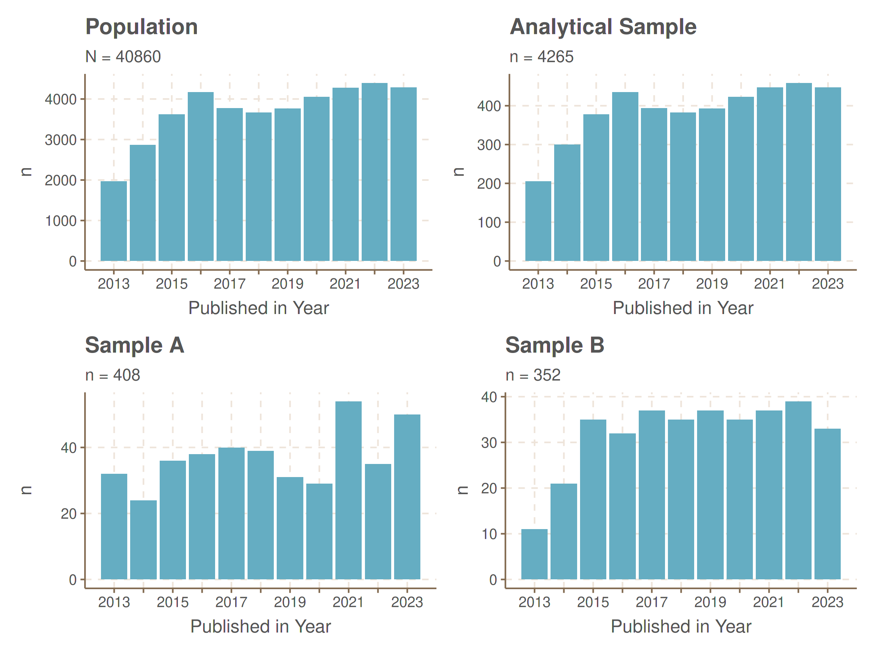
Figure 1: Frequencies: Publications by Year in Population and Sample
Using the obtained crossref metadata, the analytical sample was drawn stratified by year according to the calculation in Section 3.2. The resulting analytical sample contains roughly 10% of the population data. As seen in Figure 1, Sample A, that is the training and validation sample for the SI classifier, is intended as the proportion of SI papers are expected to not vary and therefore not stratified by year. Stratification by journal was rejected due to the resulting sample sizes of 100 journals would have required much more cases.
The final analytical sample is made up of 4265 publications. The OS prevalence classification sample consists of 352 publications stratified by year whereas the unstratified sample A for the training of the SI classifiers consists of 408 publications. The next step involved downloading full-text HTML or PDF versions, only using legal and ethical sources.

3.3.3 Full Text Retrieval
The initial approach to gathering full texts, which used Zotero to translate DOIs as per Scoggins and Robertson, was unreliable across multiple attempts and software versions. Due to the unsuitability of existing software tools, be it for technical or legal reasons, a custom web application was developed.
Downloading the analytical sample was mostly successful, though some publisher protections caused dropouts. Due to time constraints, additional more optimized runs were not feasible. Documents under 1,000 words were considered non-full-text papers. However, shorter HTML texts were retained for potential keyword matching. Text quality assessment (Flesch-Index) and word count identified missing full texts (Benoit et al., 2018). Full texts were downloaded for Independent Sample A and the Analytical Sample from which Sample B was drawn. The resulting dropouts were expected to have been implicitly handled by post-stratification, but publisher-level weighting was planned and considered but infeasible due to sparse cells that would have produced unstable weights. Post-stratification was conducted by year only, which does not correct publisher- or journal-specific dropouts. Future, non-piloting iterations should add publisher-level adjustment.

3.4 Classification Tasks and Methods
This section will present a brief summary of all methods used to classify the variables of interest. A thorough discussion of the decisions taken, the full descriptions and specifications of the models used as well as the preprocessing steps can be found in the supplied materials.
Since most existing classification approaches considered were deemed unsuitable for this scope (e.g., Kim and Gil (2019); Sanguansat (2012); Jandot et al. (2016)), this work instead relies on Random-Forest and XGBoost-models trained on a manually and LLM coded subset of publications as LLMs have shown good performance on similar classification tasks (Bunt et al., 2025; Zhao et al., 2024).
For each task, OSP-specific document-feature-matrices using term frequencies or TF-IDF of keyword sets, partly adapted from Scoggins and Robertson (2024), were constructed.
First, a strict dichotomous operationalization of “SI” or not SI, as well as of the OSPs was synthesized and documented in a short coding manual. A subset of Sample A was coded by hand, followed by a ChatGPT-based labelling of the fulltext. On a random subsample, agreement after reconciliation was high ($κ$ $≈$ .83), so combined manual/LLM labels served as training and test data for the ML classifiers. A similar approach was used for Sample B. Each OSP classifier was tuned on all possible combinations of different feature sets and model.
Given time constraints and the pilot nature of the study, preprocessing and evaluation were optimized for the OSP classifier only, not for the SI classifier. The more rigorous workflow applied to OSP - designed to handle high computational demands and substantial class imbalance - would likely also have improved SI performance, but was not pursued because SI results were already satisfactory, as documented in the provided material. Furthermore, journal-level adoption of OSPs was originally intended to be assessed using the Transparency and Openness Promotion Factor (Nosek et al., 2015). However, as the available sample sizes were insufficient for journal-level analyses, these were not carried out.

3.5 Analysis
The research was deliberately designed to study open-science practices via supervised classifiers rather than relying exclusively on metadata. This choice prioritized scalability and the potential to capture practice signals that metadata may miss, at the cost of managing model error and class imbalance. Given the exploratory character of the work, the analyses were not pre-defined, only data collection, sampling, and the model-training strategy were specified in advance. Concerns about classifier interpretability informed the evaluation strategy (Gilpin et al., 2018).
Estimates for OSPs are domain-estimates among SI papers (see Table 2) drawn from a year-stratified random sample, beta-method CIs are based on design-based variance. Design-weights were applied post-stratified to frame-by-year totals with finite-population corrections. All OSP estimates are domain estimates for SI papers using design-based inference. Design corrected 95% confidence intervals are computed with the beta method (Clopper-Pearson) transformation which provides better coverage for low-prevalences than Wald intervals (Agresti, 2007).
Results generalize to the keyword-filtered data. With $n=1,763$ SI papers, SI-domain CIs are wider than the planned $±$ 1.5 pp. Because some SI papers may have been excluded by the screening, OSP levels for all SI papers in the full corpus of 90k publications may differ. An audit of excluded records could quantify the coverage and enable adjustment but was not conducted here.
OSP labels were assigned by classifiers whose sensitivity and specificity are imperfect, with potential misclassifications affecting the reported prevalence rates. To assess robustness, a simple sensitivity analysis using the Rogan-Gladen correction for misclassification of a binary outcome was conducted (Liu et al., 2023; Valle Campos, 2020).
Data is reported per year. As per year data given the very low prevalences is extremely sparse, domain estimates for the full time period are reported as estimates of the prevalence throughout the years. OA could have been reported separately, simply adjusted using sampling weights, as it’s measured for the full sample using metadata which is expected to reflect true prevalence, but is shown along the other OSPs for consistent interpretability.

4. Results & Discussion
Two research questions were formulated: $RQ_{1}$ on the prevalence of OD and OM among statistical-inference (SI) publications, and $RQ_{2}$ on the prevalence of preregistration. After extensive model development, validation, calibration, thresholding, and misclassification adjustment, prevalences for OD, OM, and Preregistration were too low for the ML classifiers to yield interpretable, adjusted estimates.
Table 3: Sample Characteristics by Statistical Inference Status
 |  | Statistical Inference
Variable | Overall  N = 3,997¹ | No  N = 2,234¹ | Yes  N = 1,763¹ | p-value²
Open Access | 1,541 / 3,997 (39%) | 820 / 2,234 (37%) | 721 / 1,763 (41%)
Open Data | 38 / 1,763 (2.2%) | 0 / 0 (NA%) | 38 / 1,763 (2.2%)
Unknown | 2,234 | 2,234 | 0
Open Materials | 75 / 1,763 (4.3%) | 0 / 0 (NA%) | 75 / 1,763 (4.3%)
Unknown | 2,234 | 2,234 | 0
Preregistration | 63 / 1,763 (3.6%) | 0 / 0 (NA%) | 63 / 1,763 (3.6%)
Unknown | 2,234 | 2,234 | 0
Text Source |  |  |  | <0.001
HTML | 336 / 3,997 (8.4%) | 278 / 2,234 (12%) | 58 / 1,763 (3.3%)
PDF | 407 / 3,997 (10%) | 265 / 2,234 (12%) | 142 / 1,763 (8.1%)
TXT | 3,254 / 3,997 (81%) | 1,691 / 2,234 (76%) | 1,563 / 1,763 (89%)
Only Abstract | 544 / 3,997 (14%) | 477 / 2,234 (21%) | 67 / 1,763 (3.8%) | <0.001
Journal Category³
A³ | 1,986 / 3,997 (50%) | 631 / 2,234 (28%) | 1,355 / 1,763 (77%)
B³ | 1,618 / 3,997 (40%) | 1,470 / 2,234 (66%) | 148 / 1,763 (8.4%)
C³ | 393 / 3,997 (9.8%) | 133 / 2,234 (6.0%) | 260 / 1,763 (15%)
JIF Quartile
Q1 | 3,811 / 3,997 (95%) | 2,118 / 2,234 (95%) | 1,693 / 1,763 (96%)
Q2 | 174 / 3,997 (4.4%) | 109 / 2,234 (4.9%) | 65 / 1,763 (3.7%)
Q3 | 12 / 3,997 (0.3%) | 7 / 2,234 (0.3%) | 5 / 1,763 (0.3%)
Count: Words | 8,703 (6,745) | 6,977 (6,584) | 10,889 (6,300) | <0.001
Flesch Score | 26 (12) | 23 (13) | 29 (10) | <0.001
JIF (2023) | 4.7 (3.6) | 3.8 (3.8) | 5.9 (3.1) | <0.001
¹n / N (%); Mean (SD)
²Fisher's exact test; Pearson's Chi-squared test; Wilcoxon rank sum test
³A: Psychology, Multidisciplinary; B: Law; C: Criminology & Penology
The ML classifiers trained on GPT labels inherit GPT’s strengths and the data’s sparsity. For the relatively small 20% validation set coded by GPT, the open-science practice classifiers are less precise and less reliable than the Statistical-Inference classifier. In contrast, a question that was not originally foregrounded proved answerable: the prevalence and trajectory of OA among SI publications, measured from metadata with high reliability, show clear increases over time.
Before misclassification adjustment, design-based prevalences were estimated among SI papers with 95% CIs. For outcomes identified by the ML classifiers (OD, OM, Preregistration), these reflect survey-design uncertainty only.
Figure 2 shows a steady rise in OA from ~20% in 2013 to ~50% in 2023, while the other practices suffer from extremely low counts; for some years (e.g., 2013 OD; 2016 Preregistration) estimates were not possible.
Table 4 confirms low prevalences across the full period: OA $40.9\%$ (38.8-43.1), OM $4.3\%$ (3.4-5.3), Preregistration $3.6\%$ (2.8-4.5), and OD $2.2\%$ (1.6-2.9).
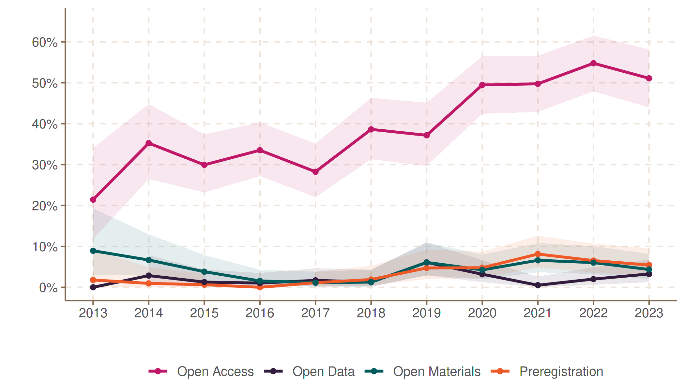
Figure 2: OSP Adoption Over Time, among statistical inference papers (design-weighted)
In parallel, Table 3 suggests systematic differences between SI and non-SI papers: distributions of text sources differ (likely reflecting publisher effects or text-quality variation), abstracts-only are more common among non-SI items, word counts are higher for SI papers, journal impact is higher, and OA appears more common. Several contrasts are statistically significant (many $p<.001$), but these should be treated as descriptive given unmodeled multilevel variance and field composition.
Table 4: Overall Prevalence of Open Science Practices among Statistical Inference Papers (Design-Weighted to Frame-by-Year Totals)
OSP | Prevalence
Open Access | 40.9% (38.8-43.1)
Open Materials | 4.3% (3.4-5.3)
Preregistration | 3.6% (2.8-4.5)
Open Data | 2.2% (1.6-2.9)
In Table 5, adjustments were applied using sensitivity and specificity from the ML-validation analysis in (Liu et al., 2023). Under extreme rarity, adjustments become unstable: intervals widen dramatically (approaching $\left[0,1\right]$) or yield boundary/negative estimates when specificity is insufficient relative to prevalence. For OD, the false-positive rate ($1−\text{Sp}≈12.7\%$) exceeds the observed prevalence ($2.2\%$), pushing adjusted points below zero. For OM, low sensitivity ($\text{Se}=0.20$) and tiny validation counts produce near-uninformative intervals. Given these constraints, the adjusted values can be interpreted as sensitivity ranges rather than confirmatory estimates. Any substantive claims should thereby rather be based on design-based estimates and on OA (measured from metadata).
Table 5: Observed and Adjusted Prevalence of Open Science Practices among Statistical Inference Papers
OSP | Obs. (95% CI) | Adj. (95% CI) | Seª | Sp^{b} | Pos^{c} | Neg^{d}
Open Data | 2.2% (1.5-2.8) | -12.1% (0.0-4.6) | 1.00 | 0.87 | 7.00 | 63.00
Open Materials | 4.3% (3.4-5.2) | 21.4% (0.0-100.0) | 0.20 | 1.00 | 1.00 | 69.00
Preregistration | 3.6% (2.8-4.4) | 2.1% (0.0-15.3) | 1.00 | 0.98 | 4.00 | 66.00
ªSensitivity
^{b}Specificity
^{c}Number of positive cases in validation set
^{d}Number of negative cases in validation set
Earlier differences in text sources suggest heterogeneity by journal, thereby implicating also publisher variance (Scoggins and Robertson, 2024). Figure 3 visualizes OA shares over time for the 12 most prolific publishers in the sample (listed in the caption). Leveraging larger $n$, the author fit simple OLS trends to annual OA proportions. The four most prolific publishers show clear increases. Four publishers do not: Oxford University Press, Emerald, ASCE, and MDPI. MDPI remains at 100% OA, Emerald at 0% in this sample; ASCE shows an apparent decline consistent with limited observations; Oxford University Press is relatively stable. All observed increases are highly statistically significant. Future work should use models designed for proportions (e.g., binomial GLMs) and, ideally, hierarchical pooling across publishers and years.
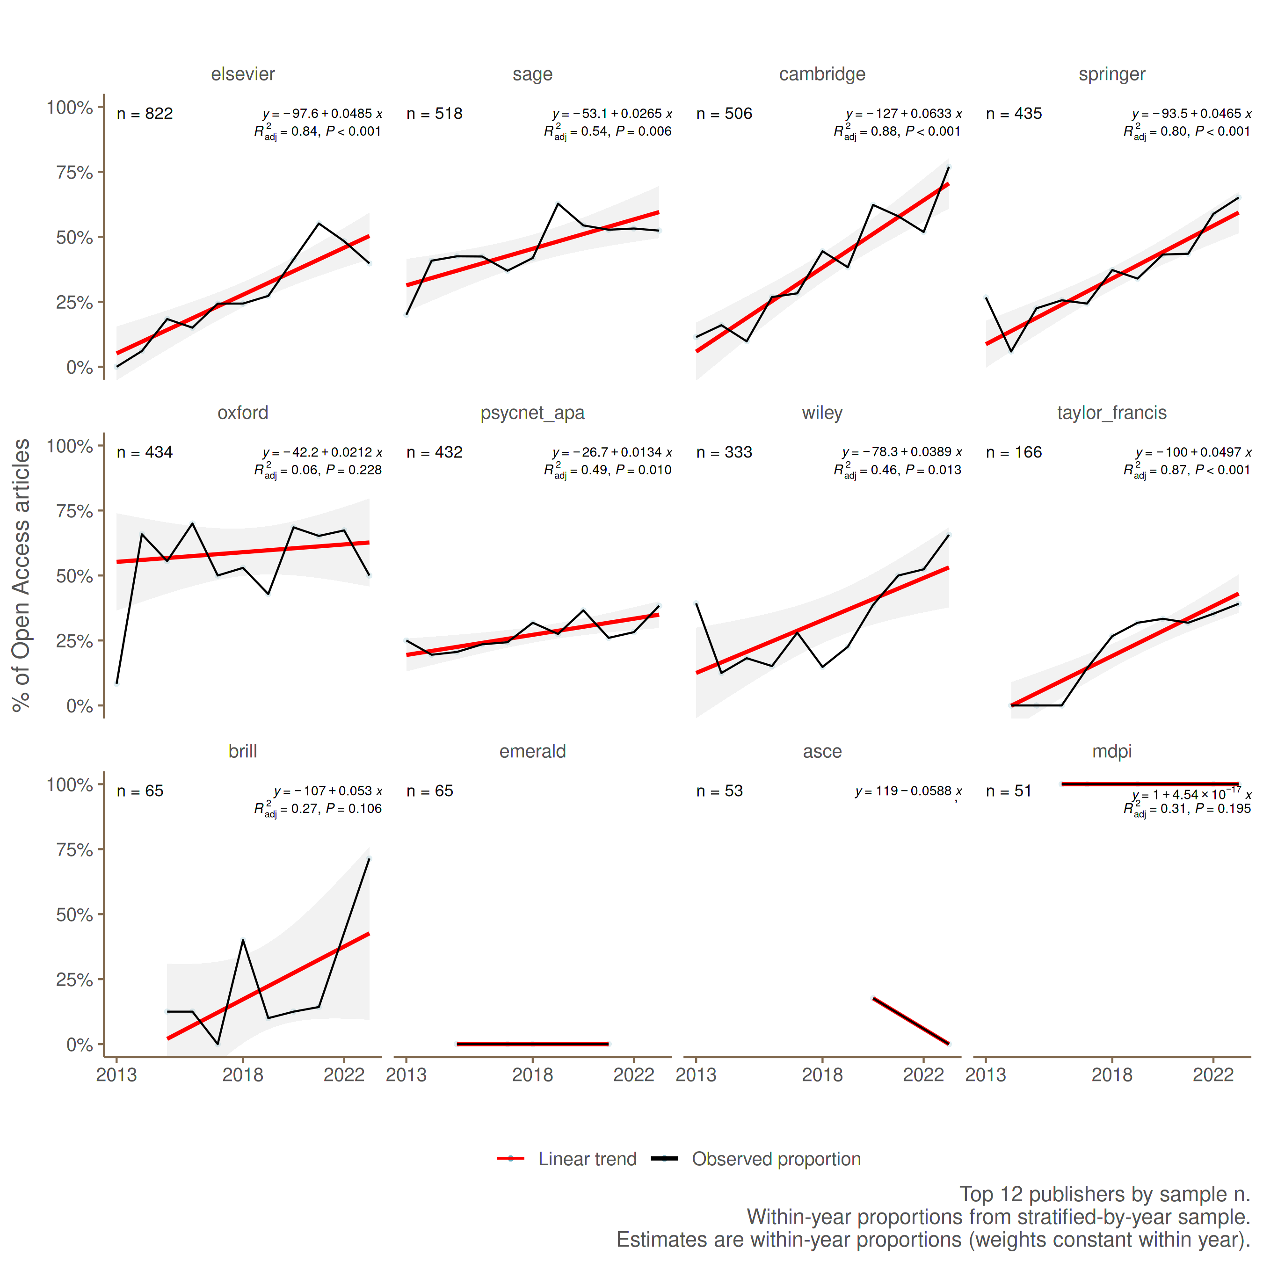
Figure 3: Open Access by Publisher over Time.
This study was deliberately scoped as a pilot, which constrained coverage, precision, and tooling. The population assessed was limited to SI papers from the top 100 JCR journals in criminology and legal psychology and to Crossref metadata, so venue and index biases remain. The 2013-2023 window omits the most recent changes. Keyword screening did not fully exclude non-target items, and a Quarto “freeze” configuration led to using print over online dates in some cases. Full-text retrieval was partial and legally bounded to TDM-permitted publishers; short documents (<1,000 words) were treated as missing full text, risking misclassification.
Measurement and modeling challenges were substantial. SI/OSP labels were trained on a small, single-coder hand set plus GPT assistance. Severe class imbalance for OSPs, few validation positives, and upsampling inflated nominal accuracy while depressing stability. Misclassification adjustments (Rogan-Gladen) became unstable at very low prevalences, and some OA trend analyses used simple OLS rather than binomial/GLM approaches.
In the methodological report, comparing basic text characteristics between OSP-labeled papers and non-OSP papers revealed non-independence (e.g., differences in word count, Flesch score, and text source), despite the assumption that such features should not vary with true OSP status. This pattern indicates likely misclassification and/or model leakage, with classifiers picking up irrelevant proxies (publisher templates, document length) rather than OSP content.
I therefore propose a series of recommendations for future iterations, that should expand bibliographic metadata sources (Crossref + Scopus and Web of Science) and further audit screened-out records to assess selection, operationalizations with sharper rules more close to the constructs defined by e.g. OSF, employ multi-coder assessment, and quantify inter-rater-reliability on a larger training data base OR classify leveraging ChatGPT as implied by the very accurate precisions evident here and replace OLS with binomial GLMs or hierarchical models for proportions. On the technicals side, a more stringent Quarto setup should be used, with simplified modular code based on a refined version of the codebase used here. The downloader should be improved in terms of a more homogeneous extraction logic by including the HTML and PDF full-text extraction in the pre-processing pipeline, making the whole process more transparent, reproducible and less error-prone. Finally, the sample size should be increased substantially, ideally to the full population of SI papers in the frame, to improve precision and enable analysis on journal level.
Despite of all the limitations, there are main substantive implications: OSP prevalence signals in SI papers-especially preregistration and OM-are rare enough that model-based estimation is fragile at this scale, whereas OA, measured from metadata, shows a clear upward trend approaching roughly half of SI outputs by 2023. Methodologically, GPT proves to be a promising primary coder for a scaled follow-up, and the pipeline developed here provides a reproducible, yet improvable foundation for a larger, better-powered study.

5. Conclusion
The replication crisis has intensified the examination of research practices and accelerated the push for transparency and openness. This study contributes by mapping the adoption of open-science practices (OSP) within criminology and legal psychology, establishing a baseline for future efforts. The evidence indicates meaningful progress in availability-most clearly in OA-yet massive, persistent gaps in reproducibility, particularly for OD, OM, and preregistration.
Two decades ago, Ioannidis (2005) argued that the credibility of findings are closely tied to statistical power, field-specific protocols, and careful attention to pre-study odds. In other words, simply assessing p-values in a rather mechanistic manner is insufficient Colling and Szűcs (2021). In that spirit, this work emphasizes measurement, validation, and transparency over nominal statistical “wins,” offering an initial, field-specific picture of where credibility can be strengthened and how to get there.
Methodologically, the study shows that GPT-assisted coding can be accurate and scalable for detecting OSPs, while downstream ML classifiers struggle under extreme class imbalance-a limitation that complicates misclassification-adjusted prevalence estimation. Still, the pipeline built here demonstrates a path toward for larger, confirmatory follow-ups.
This work discussed the replication crisis, its implications for criminology and legal psychology, and how OSPs can help to address some of the issues that have been raised. While the last decades the wording “crisis” framed the discussion in a rather negative light, recent work suggests an upward trend in OSPs which accelerates the transition towards more credible research-moving “from crisis to credibility” Korbmacher et al. (2023). Awareness and adoption of open practices are growing (Grossmann, 2021b), institutions are adapting norms and incentives (Smaldino et al., 2019). Even though the results of this study indicate that there is still a long way to go, the upward trend in OA and the presence of OM and preregistration in some papers are encouraging signs
To make sure, that our results are robust, reliable and credible, this work shall be seen as a call for an open, cumulative, and collaborative research culture. Accordingly, the author invites direct reproduction and incremental improvement of this pipeline-via open sharing of data, code, prompts, and labeling protocols-so the analysis can be stress-tested, recalibrated, and strengthened.

Acknowlegments
I would like to thank my advisor, [Advisor Name], for his guidance, constructive feedback, and steady support throughout this project. His expertise and encouragement were invaluable in shaping both the research and this publication.

Data availability
Materials, Data and Code are made available at a public OSF-repository that can be accessed here:
- https://osf.io/rvpc3/overview?view_only=0307dc0d99f74b50a738720a4a757aa0.
Further instructions can be found in the README files. Full-text data and the downloader can’t be made available to the public due to copyright concerns.

Funding
This research received no external funding.

Conflict of interest
One of the editors of this special issue participated as an academic advisor.

Author Biography
Michael Beck is finishing his MSc in Sociology and Social Research at the University of Cologne, Germany. He is interested in computational social science and supports research as a student assistant at the German Institute for Adult Education (Bonn), focusing on evaluating generative AI for education and educational research.

Bibliography
Agresti A (2007) An Introduction to Categorical Data Analysis. 2nd ed. Wiley series in probability and statistics. Hoboken (N.J.): Wiley-Interscience.
Agresti A and Coull BA (1998) Approximate Is Better than "Exact" for Interval Estimation of Binomial Proportions. The American Statistician 52(2). [American Statistical Association, Taylor & Francis, Ltd.]: 119–126.
Akbaritabar A and Squazzoni F (2021) Gender Patterns of Publication in Top Sociological Journals. Science, Technology, & Human Values 46(3). SAGE Publications Inc: 555–576.
Akker OR van den, Weston S, Campbell L, et al. (2021) Preregistration of secondary data analysis: A template and tutorial. Meta-Psychology 5.
American Psychological Association (n.d.) Open Science Badges. https://www.apa.org. https://www.apa.org/pubs/journals/resources/open-science-badges.
Auspurg K, Hinz T and Schneck A (2014) Ausmaß und Risikofaktoren des Publication Bias in der deutschen Soziologie. KZfSS Kölner Zeitschrift für Soziologie und Sozialpsychologie 66(4): 549–573.
Banks GC, Field JG, Oswald FL, et al. (2019) Answers to 18 Questions About Open Science Practices. Journal of Business and Psychology 34(3): 257–270.
Bargh JA, Chen M and Burrows L (1996) Automaticity of social behavior: Direct effects of trait construct and stereotype activation on action. Journal of Personality and Social Psychology 71(2). US: American Psychological Association: 230–244.
Begley CG and Ellis LM (2012) Raise standards for preclinical cancer research. Nature 483(7391). Nature Publishing Group: 531–533.
Benoit K, Watanabe K, Wang H, et al. (2018) Quanteda: An R package for the quantitative analysis of textual data. Journal of Open Source Software 3(30): 774.
Bland JM (2009) The tyranny of power: Is there a better way to calculate sample size? BMJ 339. British Medical Journal Publishing Group: b3985.
Breznau N (2021) Does Sociology Need Open Science? Societies 11(1). Multidisciplinary Digital Publishing Institute: 9.
Breznau N, Rinke EM, Wuttke A, et al. (2022) Observing many researchers using the same data and hypothesis reveals a hidden universe of uncertainty. Proceedings of the National Academy of Sciences 119(44). Proceedings of the National Academy of Sciences: e2203150119.
Briggs WM (2023) A partial solution for the replication crisis in economics. Asian Journal of Economics and Banking 7(2): 180–190.
Budapest Open Access Initiative (2002) Read the declaration. Budapest, Hungary.
Bunt HL, Goddard A, Reader TW, et al. (2025) Validating the use of large language models for psychological text classification. Frontiers in Social Psychology 3. Frontiers.
Callaway E (2011) Report finds massive fraud at Dutch universities. Nature 479(7371). Nature Publishing Group: 15–15.
Chick SE and Frazier P (2012) Sequential Sampling with Economics of Selection Procedures. Management Science 58(3). INFORMS: 550–569.
Chin JM, Pickett JT, Vazire S, et al. (2023) Questionable Research Practices and Open Science in Quantitative Criminology. Journal of Quantitative Criminology 39(1): 21–51.
Clarivate (2023) Journal Impact Factor. https://jcr.clarivate.com/jcr/browse-journals.
Colling LJ and Szűcs D (2021) Statistical Inference and the Replication Crisis. Review of Philosophy and Psychology 12(1): 121–147.
Crocker J (2011) The road to fraud starts with a single step. Nature 479(7372). Nature Publishing Group: 151–151.
Delgado-Quirós L, Aguillo IF, Martín-Martín A, et al. (2024) Why are these publications missing? Uncovering the reasons behind the exclusion of documents in free-access scholarly databases. Journal of the Association for Information Science and Technology 75(1): 43–58.
Diekmann A (2022) II. 2. Probleme der Prüfung von Hypothesen. In: Empirische Sozialforschung: Grundlagen, Methoden, Anwendungen. 15. Auflage, vollständig überarbeitete und erweiterte Neuausgabe August 2007, Originalausgabe. rowohlts enzyklopädie. Reinbek bei Hamburg: Rowohlt Taschenbuch Verlag.
Dienlin T, Johannes N, Bowman ND, et al. (2021) An Agenda for Open Science in Communication. Journal of Communication 71(1): 1–26.
Doyen S, Klein O, Pichon C-L, et al. (2012) Behavioral Priming: It’s All in the Mind, but Whose Mind? PLoS ONE 7(1): e29081.
Evans TR, Branney P, Clements A, et al. (2023) Improving evidence-based practice through preregistration of applied research: Barriers and recommendations. Accountability in Research 30(2). Taylor & Francis: 88–108.
Ferguson J, Littman R, Christensen G, et al. (2023) Survey of open science practices and attitudes in the social sciences. Nature Communications 14(1). Nature Publishing Group: 5401.
Fessinger MB, McAuliff BD and Perillo AD (2025) The state of open science in the field of psychology and law. Law and Human Behavior 49(1). US: Educational Publishing Foundation: 54–70.
Fink L and Marcus J (2024) Replication code availability over time and across fields: Evidence from the German Socio-Economic Panel. Economic Inquiry 63(1).
Firebaugh G (2008) The fourth rule: REPLICATE WHERE POSSIBLE. In: Seven Rules for Social Research. Princeton University Press, pp. 90–119. Available at: https://www.jstor.org/stable/j.ctv39x5wn.7 (accessed 23 August 2025).
Franco A, Malhotra N and Simonovits G (2014) Publication bias in the social sciences: Unlocking the file drawer. Science 345(6203). American Association for the Advancement of Science: 1502–1505.
Freese J (2007) Replication Standards for Quantitative Social Science: Why Not Sociology? Sociological Methods & Research 36(2). SAGE Publications Inc: 153–172.
Freese J and Peterson D (2017) Replication in Social Science. Annual Review of Sociology 43(Volume 43, 2017). Annual Reviews: 147–165.
Freese J, Rauf T and Voelkel JG (2022) Advances in transparency and reproducibility in the social sciences. Social Science Research 107: 102770.
Gerasimov I, KC B, Mehrabian A, et al. (2024) Comparison of datasets citation coverage in Google Scholar, Web of Science, Scopus, Crossref, and DataCite. Scientometrics 129(7): 3681–3704.
Gerber AS and Malhotra N (2008) Publication Bias in Empirical Sociological Research: Do Arbitrary Significance Levels Distort Published Results? Sociological Methods & Research 37(1). SAGE Publications Inc: 3–30.
Gilpin LH, Bau D, Yuan BZ, et al. (2018) Explaining explanations: An overview of interpretability of machine learning. In: Proc. - IEEE Int. Conf. Data Sci. Adv. Anal., DSAA, 2018, pp. 80–89. Institute of Electrical and Electronics Engineers Inc.
Greenspan RL, Baggett L and B. Boutwell B (2024) Open science practices in criminology and criminal justice journals. Journal of Experimental Criminology. forthcoming September 2024. DOI: 10.1007/s11292-024-09640-x.
Grossmann M (2021a) Open Science Reform and Social Science Progress. In: Grossmann M (ed.) How Social Science Got Better: Overcoming Bias with More Evidence, Diversity, and Self-Reflection. Oxford University Press, p. 0.
Grossmann M (2021b) Reasons for Cautious Optimism. In: How Social Science Got Better: Overcoming Bias with More Evidence, Diversity, and Self-Reflection. Oxford University Press, p. 0.
Hardwicke TE and Wagenmakers E-J (2023) Reducing bias, increasing transparency and calibrating confidence with preregistration. Nature Human Behaviour 7(1). Nature Publishing Group: 15–26.
Hardwicke TE, Wallach JD, Kidwell MC, et al. (2020) An empirical assessment of transparency and reproducibility-related research practices in the social sciences (2014–2017). Royal Society Open Science 7(2): 190806.
Haustein S, Bowman TD and Costas R (2015) When is an article actually published? An analysis of online availability, publication, and indexation dates. arXiv:1505.00796. arXiv. Available at: https://arxiv.org/abs/1505.00796 (accessed 15 July 2025).
Ioannidis JPA (2005) Why Most Published Research Findings Are False. PLOS Medicine 2(8). Public Library of Science: e124.
Jandot C, Simard PY, Chickering DM, et al. (2016) Interactive Semantic Featuring for Text Classification. ArXiv. forthcoming June 2016.
Jensen TI, Kelly B and Pedersen LH (2023) Is There a Replication Crisis in Finance? The Journal of Finance 78(5): 2465–2518.
John LK, Loewenstein G and Prelec D (2012) Measuring the Prevalence of Questionable Research Practices With Incentives for Truth Telling. Psychological Science 23(5): 524–532.
Kim S-W and Gil J-M (2019) Research paper classification systems based on TF-IDF and LDA schemes. Human-centric Computing and Information Sciences 9(1): 30.
Korbmacher M, Azevedo F, Pennington CR, et al. (2023) The replication crisis has led to positive structural, procedural, and community changes. Communications Psychology 1(1). Nature Publishing Group: 3.
Kühberger A, Fritz A and Scherndl T (2014) Publication Bias in Psychology: A Diagnosis Based on the Correlation between Effect Size and Sample Size. PLOS ONE 9(9). Public Library of Science: e105825.
Liu J, Wang S and Shao F (2023) Quantitative bias analysis of prevalence under misclassification: Evaluation indicators, calculation method and case analysis. International Journal of Epidemiology 52(3): 942–951.
Logg JM and Dorison CA (2021) Pre-registration: Weighing costs and benefits for researchers. Organizational Behavior and Human Decision Processes 167: 18–27.
Manago B (2023) Preregistration and Registered Reports in Sociology: Strengths, Weaknesses, and Other Considerations. The American Sociologist 54(1): 193–210.
McNeeley S and Warner JJ (2015) Replication in criminology: A necessary practice. European Journal of Criminology 12(5). SAGE Publications: 581–597.
Mertens G and Krypotos A-M (2019) Preregistration of Analyses of Preexisting Data. Psychologica Belgica 59(1).
Moneva A, Bernasco W, van de Weijer S, et al. (2025) Attitudes and barriers to open science practices: A mixed-methods analysis at a criminological research institute. De Boelelaan 1077, 1081 HV Amsterdam, The Netherlands: Preprint; Netherlands Institute for the Study of Crime and Law Enforcement (NSCR).
Munafò MR, Nosek BA, Bishop DVM, et al. (2017) A manifesto for reproducible science. Nature Human Behaviour 1(1). Nature Publishing Group: 0021.
Nosek BA, Alter G, Banks GC, et al. (2015) Promoting an open research culture. Science 348(6242). American Association for the Advancement of Science: 1422–1425.
Piwowar H, Day RS and Fridsma DB (2007) Sharing Detailed Research Data Is Associated with Increased Citation Rate. PLOS ONE 2(3). Public Library of Science: e308.
Piwowar H, Priem J, Larivière V, et al. (2018) The state of OA: A large-scale analysis of the prevalence and impact of Open Access articles. PeerJ 6. PeerJ Inc.: e4375.
Popper K (2005) The Logic of Scientific Discovery. 2nd ed. London: Routledge.
Pridemore WA, Makel MC and Plucker JA (2018) Replication in Criminology and the Social Sciences. Annual Review of Criminology 1(Volume 1, 2018). Annual Reviews: 19–38.
Roberts DR, Bahn V, Ciuti S, et al. (2017) Cross-validation strategies for data with temporal, spatial, hierarchical, or phylogenetic structure. Ecography 40(8): 913–929.
Rosenthal R (1979) The file drawer problem and tolerance for null results. Psychological Bulletin 86(3). US: American Psychological Association: 638–641.
Sanguansat P (2012) Feature matricization for document classification. In: 2012 IEEE International Conference on Signal Processing, Communication and Computing (ICSPCC 2012), August 2012, pp. 745–749.
Sarafoglou A, Kovacs M, Bakos B, et al. (2022) A survey on how preregistration affects the research workflow: Better science but more work. Royal Society Open Science 9(7). Royal Society: 211997.
Scoggins B and Robertson MP (2024) Measuring transparency in the social sciences: Political science and international relations. Royal Society Open Science 11(7). Royal Society: 240313.
Sherman LW and Berk RA (1984) The Specific Deterrent Effects of Arrest for Domestic Assault. American Sociological Review 49(2): 261.
Simmons JP, Nelson LD and Simonsohn U (2011) False-Positive Psychology: Undisclosed Flexibility in Data Collection and Analysis Allows Presenting Anything as Significant. Psychological Science 22(11): 1359–1366.
Smaldino PE, Turner MA and Contreras Kallens PA (2019) Open science and modified funding lotteries can impede the natural selection of bad science. Royal Society Open Science 6(7). Royal Society: 190194.
Tennant JP, Waldner F, Jacques DC, et al. (2016) The academic, economic and societal impacts of Open Access: An evidence-based review. F1000Research 5: 632.
Valle Campos A (2020) Serosurvey: Serological survey analysis for prevalence estimation under misclassification. Zenodo. forthcoming October 2020. DOI: 10.5281/zenodo.4065080.
Vicente-Saez R and Martinez-Fuentes C (2018) Open Science now: A systematic literature review for an integrated definition. Journal of Business Research 88: 428–436.
Wentz R (2002) Visibility of research: FUTON bias. The Lancet 360(9341). Elsevier: 1256.
Weston SJ, Ritchie SJ, Rohrer JM, et al. (2019) Recommendations for Increasing the Transparency of Analysis of Preexisting Data Sets. Advances in Methods and Practices in Psychological Science 2(3): 214–227.
Zhao H, Chen QP, Zhang YB, et al. (2024) Advancing Single- and Multi-task Text Classification through Large Language Model Fine-tuning. arXiv:2412.08587. arXiv. Available at: https://arxiv.org/abs/2412.08587 (accessed 28 March 2025).

https://jcr.clarivate.com/jcr/browse-journals, JCR Year set to 2023.

